Complete tasks, which are related to training 60:
- Locate css selectors for following elements in RMSys:
a) Selector, which grabs all links and inputs on home page;
a,input
b) Selector, which grabs all elements on home page;
*
c) Update “#info>a” (add something at the end of locator) to grab all elements near to link for your name on home page (see screenshot a);
#info>a~div
d) Chapaeva 051 link, do not use "href" attribute of link;
li:nth-child(2)>a[data-officeid]
e) Zetkin 500 link, do not use "href" attribute of link;
li:last-child>a[data-officeid]
f) Chapaeva 118 link, do not use "href" attribute of link;
li:nth-child(4)>a[data-officeid]
g) Selector, which grabs elements together – Chapaeva 118 link, Chapaeva 209 link, Chapaeva 214 link, Chapaeva 326 link, Chapaeva 417 link, Masherova 012 link;
li:nth-child(6n+4)>a[data-officeid]
h) Selector, which grabs all inputs on vacation page, except of Start Date input.
input:not(#EditVacationRequestStartDate)
- Locate xpath selectors for following elements in RMSys:
a) Selector, which grabs all links and inputs on home page;
//a | //input
b) Selector, which grabs all elements on home page;
//*
c) Update “//div[@id='info']/a” (add something at the end of locator) to grab all elements near to link for your name on home page (see screenshot a);
//div[@id='info']/a/following-sibling::div
d) Chapaeva 051 link, do not use "href" attribute of link and index;
//li/a[contains(text(),"Chapaeva 051")]
e) Zetkin 500 link, do not use "href" attribute of link and index;
//li/a[contains(text(),"Zetkin 500")]
f) Chapaeva 118 link, do not use "href" attribute of link and index;
//li/a[contains(text(),"Chapaeva 118")]
g) Selector, which grabs all elements with css classes;
//*[@class]
h) Selector, which grabs all elements with css class, which starts with “widget”;
//*[starts-with(@class, 'widget')]
i) Selector, which grabs all elements with id, which ends with “wrapper”;
ends-with – is not supported in browsers.
j) Selector, which grabs all elements with attribute “data-officeid” (attribute should contain “b” letter);
//*[contains(@data-officeid,'b')]
k) Element with text "Management Belarus";
//*[contains(text(),'Management Belarus')]
l) Update selector "//span[text()="3"]". Updated selector should point to Company link.
//parent::span[text()="3"]/parent::span/preceding-sibling::a
Screenshot a:
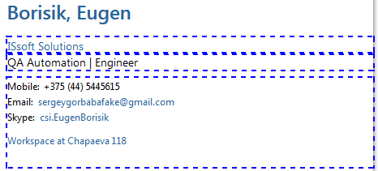
- Complete all levels of https://flukeout.github.io/

